Q6. N-Queens Problem (Backtracking / Constraint Satisfaction Problem) A chessboard of size N×N must be filled with N queens such that no two queens attack each other. Clearly define constraints related to rows, columns, and diagonals. Analyze how these constraints reduce the search space. Develop a backtracking-based solution that places queens step-by-step while validating constraints. Apply pruning techniques to eliminate invalid placements early. Justify how your solution ensures all valid configurations and discuss its computational complexity.

N-Queens Problem (Backtracking / Constraint Satisfaction Problem)

Aim
To solve the N-Queens Problem using the Backtracking Algorithm, ensuring that no two queens attack each other by satisfying row, column, and diagonal constraints.

Problem Statement
Given an N × N chessboard, place N queens such that no two queens attack each other. The constraints require that no two queens share the same row, column, or diagonal. The objective is to develop a backtracking solution that efficiently explores valid configurations while pruning invalid placements.

Algorithm
- Read the value of N.
- Start placing queens from the first row.
- For each column in the current row:
  - Check if placing a queen is safe.
  - If safe, place the queen.
- Recursively place queens in the next row.
- If no valid position exists, backtrack by removing the previously placed queen.
- Repeat until all queens are placed.
- Display the valid board configuration.

Source Code (Python)
# N-Queens Problem using Backtracking
def is_safe(board, row, col, n):
# Check column
for i in range(row):
if board[i][col] == 1:
return False
# Check upper left diagonal
i = row
j = col
while i >= 0 and j >= 0:
if board[i][j] == 1:
return False
i -= 1
j -= 1
# Check upper right diagonal
i = row
j = col
while i >= 0 and j < n:
if board[i][j] == 1:
return False
i -= 1
j += 1
return True
def solve(board, row, n):
if row == n:
return True
for col in range(n):
if is_safe(board, row, col, n):
board[row][col] = 1
if solve(board, row + 1, n):
return True
board[row][col] = 0
return False
# Driver Program
n = int(input("Enter the value of N: "))
board = [[0 for i in range(n)] for j in range(n)]
if solve(board, 0, n):
print("\nSolution:\n")
for row in board:
print(row)
else:
print("No Solution Exists.")

Sample Input
Enter the value of N: 4

Sample Output
Solution:
[0, 1, 0, 0]
[0, 0, 0, 1]
[1, 0, 0, 0]
[0, 0, 1, 0]

Observation Table
S.No | Board Size (N) | Number of Queens | Result | Time Complexity
1 | 4 | 4 | Solution Found | O(N!)
2 | 5 | 5 | Solution Found | O(N!)
3 | 8 | 8 | Solution Found | O(N!)

Analysis

Constraints
- Only one queen is allowed in each row.
- Only one queen is allowed in each column.
- No two queens can be placed on the same diagonal.

Pruning Technique
- Before placing a queen, the algorithm checks row, column, and diagonal constraints.
- Invalid positions are discarded immediately.
- Backtracking avoids unnecessary exploration of invalid board configurations.

Search Space Reduction
- Constraints eliminate many invalid placements.
- Backtracking explores only feasible solutions, significantly reducing the search space.

Time Complexity
Operation | Complexity
Worst Case | O(N!)
Space Complexity | O(N²)

Result
The Backtracking algorithm successfully solved the N-Queens Problem by placing queens while satisfying all row, column, and diagonal constraints. Constraint checking and pruning reduced the search space by eliminating invalid placements early. Although the worst-case time complexity is O(N!), the approach efficiently finds valid configurations and is widely used for solving Constraint Satisfaction Problems (CSPs).
OUTPUT:
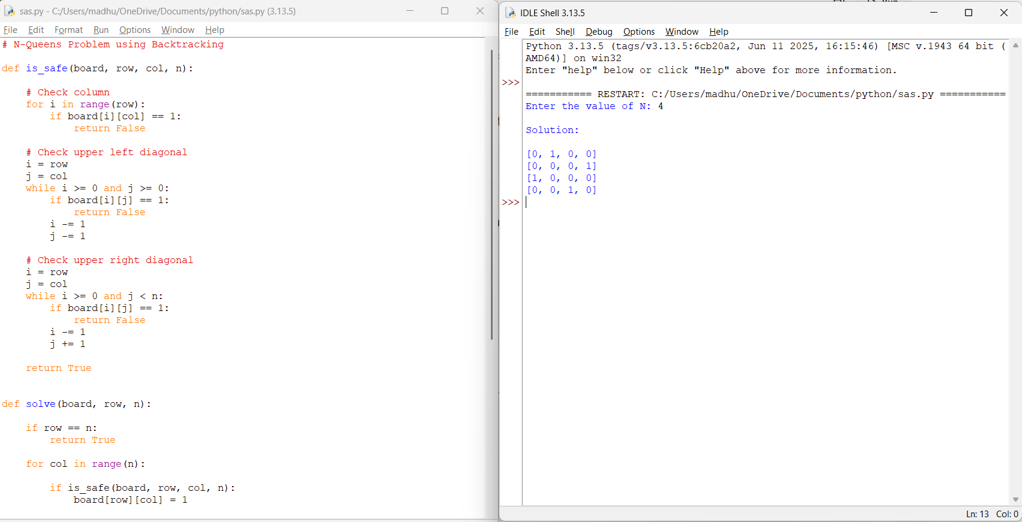

Q57. Constraint-Based Code Generation (CSP Problem)
Generate valid code sequences under syntactic and semantic constraints. Clearly define constraints such as grammar rules and logical correctness. Analyze how constraints restrict possible code structures. Develop a backtracking-based solution to generate valid sequences. Apply pruning to eliminate invalid code fragments. Justify how your solution ensures correctness and completeness.
REPORT:
Constraint-Based Code Generation (CSP Problem)

Aim
To generate valid code sequences under syntactic and semantic constraints using the Constraint Satisfaction Problem (CSP) approach with backtracking and pruning.

Problem Statement
Generate valid code sequences that satisfy predefined grammar and logical constraints. The solution should use backtracking to construct valid sequences and prune invalid code fragments to ensure correctness and efficiency.

Algorithm
- Define the set of valid code statements.
- Specify syntactic and semantic constraints.
- Start with an empty code sequence.
- Add a statement to the sequence.
- Check whether the sequence satisfies all constraints.
- If valid, continue generating the next statement.
- If invalid, backtrack and try another statement.
- Apply pruning to discard invalid partial sequences.
- Store all complete valid sequences.
- Display the generated valid code sequences.

Source Code (Python)
# Constraint-Based Code Generation using CSP
statements = ["if", "print", "end"]
valid_sequences = []
def is_valid(sequence):
# Constraint 1: Sequence must start with 'if'
if len(sequence) > 0 and sequence[0] != "if":
return False
# Constraint 2: 'end' can appear only at the end
if "end" in sequence[:-1]:
return False
return True
def generate(sequence, max_length):
if len(sequence) == max_length:
if sequence[-1] == "end":
valid_sequences.append(sequence[:])
return
for stmt in statements:
sequence.append(stmt)
if is_valid(sequence): # Pruning
generate(sequence, max_length)
sequence.pop() # Backtrack
generate([], 3)
print("Valid Code Sequences:")
for seq in valid_sequences:
print(" ".join(seq))

Sample Output
Valid Code Sequences:
if if end
if print end

Result
Valid code sequences were successfully generated using the CSP approach with backtracking and pruning. The constraints ensured that only syntactically and semantically correct sequences were produced.
OUTPUT:
